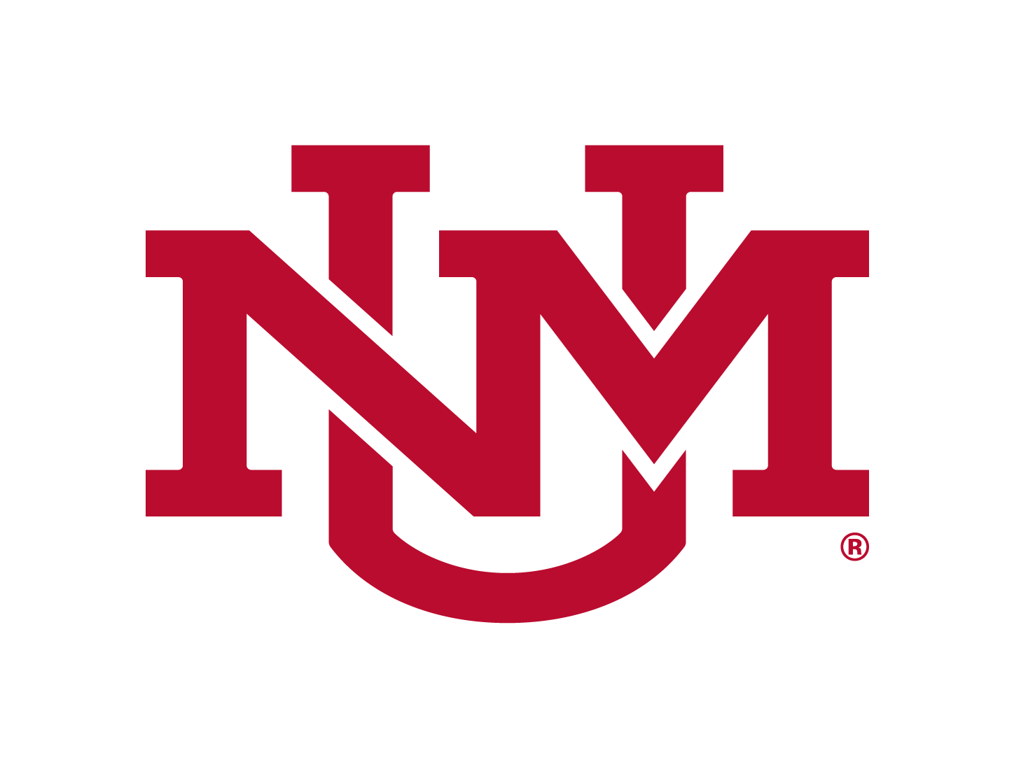

# Volunteer for a Research Study

For more information,

contact (name) at:

(123) 456-7890

[name@unm.edu](mailto:name@unm.edu)

[www.website.org](http://www.website.org)

## Contact

(123) 456-7890

## Contact

(123) 456-7890

## Contact

(123) 456-7890

## Contact

(123) 456-7890

## Contact

(123) 456-7890

## Contact

(123) 456-7890

## Contact

(123) 456-7890

## Contact

(123) 456-7890

## Contact

(123) 456-7890

## Contact

(123) 456-7890

## Project Title

The IRB wants to see the purpose of the research, a brief overview of the project’s inclusion criteria, a brief outline of what the participants will do in the research study within a specified time frame, & incentive for participation. See example/template below:

We are looking for volunteers to help us find out more about why people like to get involved with research as a research participant.

You may be eligible to participate if you…

* Are over 18 years old
* Want to find out more about research studies

Participation includes a survey and an interview that will take 2 hours.

Participants are compensated $25 for their time.