Protocol Deviations Report  The purpose of this form is to document any protocol deviations that occurred over the course of the research.  Instructions:  Use this form over the course of your approval period to record protocol deviations. Submit this form as part of the Continuing Review or Closure submission. For each deviation, please complete all columns. | 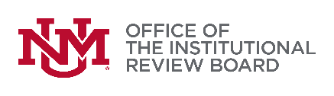  1805 Sigma Chi NE | Tel: (505) 277-2644  Website: irb.unm.edu | Email: IRBMainCampus@unm.edu

Project Identification
* IRB reference number: |  | * Project title:

Principal Investigator of Record
* The Principal Investigator of record is: (select one) |  | Principal Investigator |  |  | Responsible Faculty
* Name: |  |  | * Phone: |  |  | * Email:

Additional Contact Person
** The contact person for this project is: (select one) |  | Student Investigator |  |  | Project Coordinator
** Name: |  |  | ** Phone: |  |  | ** Email:

Protocol Deviations
A one-time deviation from the IRB-approved protocol that involves no risks to participants or others, does not impact participant safety, compromise the integrity of the research data, or affect participants’ willingness to participate. For more information, please see SOP 405 Reporting of Protocol Deviations.
Date of Deviation: | Description of Deviation: | Cause of Deviation and Corrective Action Plan: | Was there harm?*
 |  |  | No Yes
 |  |  | No Yes
 |  |  | No Yes
 |  |  | No Yes
 |  |  | No Yes
* Important! If you indicate that there was harm, please follow SOP 401 Reporting and Review of Events Involving risk to Participants or Others

Certification
* Signature below certifies that information provided on this form is accurate.
Principal Investigator of Record |  | Student Investigator
* Signature | * Date | Signature | Date

